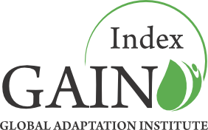

**2012 Consultation Process:**

Summary of Changes and Feedback

*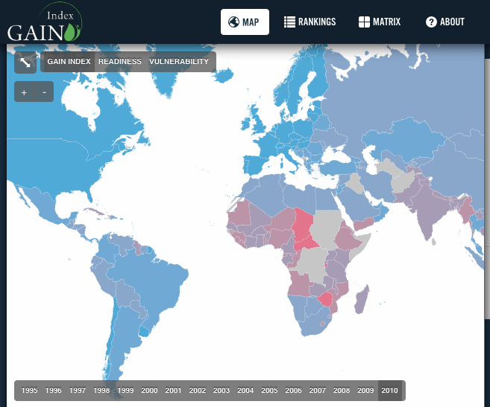*

*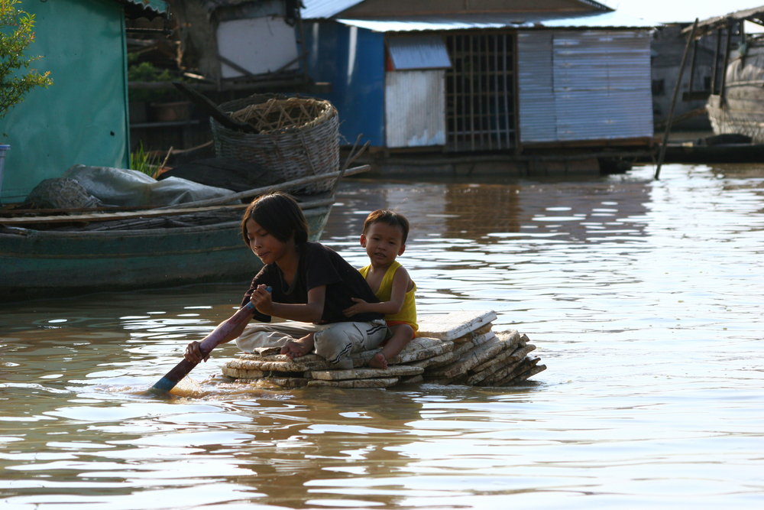*

Building Resilience to Climate Change and Other Global Challenges

Table of Contents

GAIN Leadership and Advisory Council 3

GAIN Staff 3

Council of Scientific Advisors 4

Mission for the Index 5

What makes the GAIN Index unique? 5

The consultation process 6

Summary of 2012 changes 7

Feedback: Year 1 7

GAIN Index Website Analytics 7

Presentations 10

Website source code 11

Email and personal feedback 11

GAIN Index 2012 11

Changes in the code 12

Re-sourced data 12

Tolerance for missing numbers 12

Preliminary ranking 13

Differences in the score for 2010 15

GAIN 2012 additional measures 15

Specific Open Issues 16

Website update-upgrade 16

Readiness axis 16

Complementary activities of GAIN 17

GAIN Index related projects 17

GAIN Prize (GAIN.org/Prize) 18

GAIN Knowledge (GAIN.org/knowledge) 18

# 

## GAIN Leadership and Advisory Council

**The Honorable José María Aznar**

Chairman of the Advisory Council,

Global Adaptation Institute

Mr. Aznar is the former President

of Spain (1996-2004)

**Mr. Kenneth Hersh**

GAIN Board of Directors Chairman

NGP Energy Capital Management CEO

**Dr. Juan Jose Daboub**

GAIN Founding CEO

Former World Bank Managing Director

**Mr. Anthony Morris**

Founder, The Morris Company

**Ms. Ana Palacio**

GAIN Advisory Council Member

Foreign Minister of Spain (2002-2004)

**The Honorable Jorge Quiroga**

President of Bolivia (2001-2002)

Vice President of Bolivia (1997-2001)

**Mr. Andreas Widmer**

Co-Founder, Seven Fund

Co-Founder, Seven Fund

## GAIN Staff

# **Dr. Ian Noble** Chief Scientist

# **Tim Wierzbicki** Vice President of Development

# **Jessica Siegel Weaver** Vice President of Finance & Administration

# **Dr. Bruno Sanchez-Andrade Nuño** Director of Science & Technology

# **Jamie Carson** Director of Communications

# **Carmen Tobar** Senior Advisor

# **Davis Cherry** Development & Communications Associate

## Council of Scientific Advisors

**Dr. María de Lourdes Dieck Assad**

Director General of Graduate Schools of Business and Government

ITESM – Tecnológico de Monterrey**, Mexico**

**Dr. Hans-Martin Füssel**  
Project Manager for Climate Impacts, Vulnerability, and Adaptation  
European Environment Agency, Denmark

**Dr. Steve Hanke**  
Professor of Applied Economics

Co-Director, The Institute for Applied Economics, Global Health and the Study of Enterprise

Johns Hopkins University

**Dr. Richard Moss**  
Senior Staff Scientist

Pacific Northwest National Laboratory Joint Global Change Research Institute, United States

**Dr. Mark Myers**  
Vice Chancellor of Research  
University of Alaska, United States

**Dr. Anand Patwardhan**  
Professor, Shailesh J Mehta School of Management  
Indian Institute of Technology-Bombay, India

**Dr. Pablo Spiller**

Jeffrey A. Jacobs Distinguished Professor of Business & Technology

Haas School of Business

University of California, Berkeley

Visiting Professor of Law, Columbia University

**Dr. Caroline Sullivan**  
Associate Professor  
School of Environmental Science and Management  
Southern Cross University, Australia

**Dr. Claudio Szlafsztein**  
Professor, Center of Environmental Sciences  
Federal University of Pará, Brazil

**Dr. Jintao Xu**

Professor of Natural Resource Economics

Chair, Department of Environmental Management

National School of Development, Peking University, China

# 

# **Mission for the Index**

Adaptation is imperative. The world is changing fast. Countries are being challenged to prepare for and, if possible, minimize the effects of climate change. The challenge will only be greater as populations and economies grow. People around the world experienced a variety of sudden as well as gradual disasters in 2012. From a record-breaking drought in the United States to unprecedented flooding in Thailand, governments, businesses and communities had to grapple with massive losses stemming from the inability of the affected agricultural, energy, water and urban systems to cope with these changes.

These events forced the world to reflect on how to deal with increasing disasters. Meanwhile, the Global Adaptation Institute (GAIN) has been busy consulting with government, business, academic and civil society leaders around the world on how to measure and improve all societies' ability to adapt to the global forces of climate change, population and economic growth and urbanization.

Since its release September 14, 2011, we have presented the GAIN Index to audiences on six continents and more than two dozen think tanks, governmental bodies and businesses.

We are now preparing the first update of the Index. This document summarized the most important changes and lessons learned since launch, as well as some open questions.

## What makes the GAIN Index unique?

The GAIN Index is not the first attempt at measuring the vulnerabilities of countries to climate change and other global forces. Scientists and institutions around the world have conducted significant work throughout the last decade. The GAIN Index seeks to build upon this previous work by creating an index that promotes pragmatic action among governments, the private sector and NGOs; it also uniquely combines the concepts of vulnerability with readiness to drive action. Further, the Index:

* Is open and transparent – All indicators and sources are readily available and accessible to the public.
* Brings the private sector to the table – Most indices focus solely on the vulnerabilities of countries; the GAIN Index includes indicators that guide governments and communities in how to prioritize action and harness the power of the private sector.
* Focuses on sectors crucial to human well-being – The GAIN Index does not cover all aspects of vulnerability, but targets those sectors most important to human health and prosperity that also can be greatly improved by innovation.
* Tracks changes in countries’ vulnerability and readiness from 1995 to present.
* The GAIN Index has a simple but effective structure that allows for expansion of its coverage and the substitution of better indicators as they become available.
* Aims to serve as a tool for both pragmatic policy makers and business people.

# The consultation process

GAIN solicits input from various stakeholder groups working on adaptation – private sector companies, scientists, governments, international organizations, NGOs and others. This is accomplished through various mechanisms, such as this consultation, presentations throughout the year and via web analytics and email support. You can consult our White Paper at [index.gain.org/about](http://index.gain.org/about" \t "_blank).

The purpose of this consultation is to assist GAIN in making the Index as effective as possible. These reviews not only fulfill GAIN’s institutional priority to be open, transparent and pragmatic, but also provide us with preliminary reactions from a diverse group of users and experts and, as a result, enhance the clarity, practicality, and credibility of the final Index.

We ask reviewers to consider whether, in their judgment, the arguments and decisions presented are sound and the Index is responsive to its stated goals and the feedback received, not if reviewers concur with the findings.

The content of the comments are registered online, together with our response. This helps us build a continuous open process of improvement. To encourage reviewers to express their views freely, reviews can be confidential and won't be published. The list of names and affiliations of participants in the review will be made public when the Index is released, but comment authorship will remain confidential.

With the consultation process we aim to answer these questions:

1. Is the goal of the Index clearly described? Is the Index responsive to these goals?
2. Are the metric framework decisions and consequences adequately documented, supported and explained?
3. Are uncertainties or incompleteness recognized and addressed for future work?
4. Are the data and analyses handled competently? Are statistical methods applied appropriately?
5. Is the Index fair? Is it impartial and fact based?
6. What other significant improvements might be made in the Index?

# **Summary of 2012 changes**

The 2011 GAIN Index, framework and methodology were released in September 2011 and remain the basis of the GAIN Index website. During the past year the focus of the Institute has been on communications and fundraising around the Index. The GAIN technical team has concentrated on supporting users of the index and gathering user feedback, and a complete internal audit of the software and data. Following the recommendations from last year, GAIN has drafted additions to the Index (indicators that measure ecosystem services and human habitat). GAIN is also considering improving the Readiness Axis, but not until the 2013 release.

## Feedback: Year 1

### GAIN Index Website Analytics

Embedded within the Index website is a Google Analytics tracking code, which provides an estimate[[1]](#footnote-1) for visits, and includes important information such as navigation through the site, time per visit, and source of the visit.

Analytics for the GAIN Index website during the last year (from the Sept. 14, 2011 launch until July 24, 2012) include:

* Approximately 30,000 visits, of which at least 20,000 are unique visitors.
* Each visitor viewed about three pages per visit, giving at total of 85,463 page views.
* The average visit duration was four minutes and twenty-one seconds.

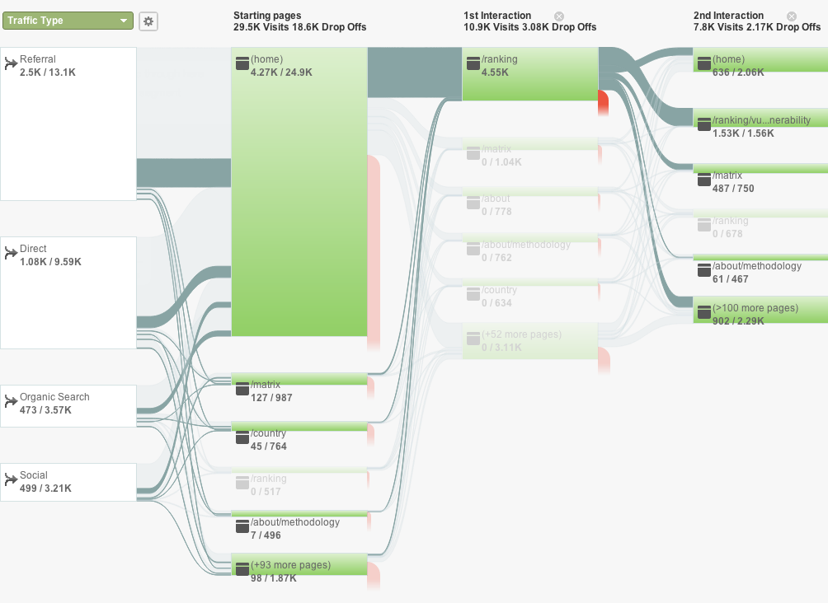

Figure 1. Visitor flow. From left to right, the first column is the breakdown by entry type: referral (link from another website), direct (typing the sites URL), ‘organic’ (from listings on search engine results pages like Google) or from social networks, the following breaks down the pages visited. Lines between columns show the thread of usage. Red lines represent the end of the visit. The highlighted connecting path shows those users who visited the Ranking page on their first interaction on the site. Numbers below each green block correspond to visits towards this highlighted path, versus total views.

The visitor flow graph shows that the homepage is the most visited page, and the biggest attractor is the rankings page.

After the month of the launch, which had a peak of 12.000 page views the baseline is roughly 1,000 page views/week with returning visitors representing a steady 50 percent of visits per week.

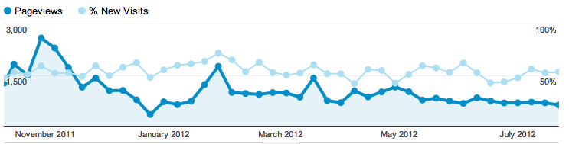

Figure 2. Timeline of page views per week from October 2011 to July 2012 in dark blue, and light blue for the percentage of new visitors.

Figure 3. Breakdown of page views on index.gain.org from Sept 2011 to July 2012.

Most of the views are of the front page, which is also the most common landing page, as we can also see on the flow chart. The GAIN Index Rankings page is the second most visited (12% ), which confirms its importance (i.e. users are twice as interested in viewing the Rankings compared to the Methodology (5 percent).

Figure 4. Top 6 traffic sources for index.gain.org from Sep 2011 to July 2012. The green section [gain.org / globalai.org] corresponds to the Institute´s page.

Half of the traffic is *direct*, meaning visitors with an unknown source (typing the URL address, bookmarks or some email clients). *Organic* sources (from listings on search engine results pages like Google) are steady around 17 percent. Interestingly, two high-traffic websites alone have provided more inbound links than the organic search traffic.

Regarding search terms, the list includes obvious search terms such us “Global Adaptation Index”, “GAIN Index.” Other common entry keywords include terms such as “Adaptation Index” (the 9th most common entry keyword — the GAIN Index is the first page to show up in Google for that search query).

Some country specific profile pages are in the top 100 search terms as well. These include Chad, the 10th most searched term, Mongolia, the 28th most common entry point via keywords, as well as Denmark, Australia and the U.S.

Thus, most common pathway is a referral to the front page, where the user is lead to the Rankings. The Matrix page is the second most common landing page, but with far fewer visits than the home page. Interestingly the Matrix is the most highlighted part in our presentations, but it seems to be not properly captured or used in the layout of the website.

### Presentations

Given the focus on expanding the user base for the index, GAIN staff has been active in making presentations to a wide range of companies, consultancies, think tanks, government and non-government institutions, and technical forums. This is a short Summary of some of the presentations GAIN has made since September 2011.

* Presentation with Calvert Investments, September 16, 2011, Bethesda, Maryland
* Panel discussion, *Rethinking Resiliency*, during NYC Climate week, September 21, 2011
* European Ideas Network in Bucharest, Romania, September 22, 2011
* Inter-American Development Bank, October 7, 2011, Washington, DC
* GAIN Index presentation, Tecnológico de Monterrey webcast throughout Latin America, November 3, 2011
* Carnegie Moscow Center, Carnegie Endowment for International Peace, Moscow, November 9, 2011
* GAIN Index Presentation to Latin American Ambassadors to the U.S., November 15, 2011
* Presentation to the UNFCCC Secretariat, Bonn Germany, November 15, 2011
* Meeting of international vulnerability experts, “Workshop on Vulnerability Indices,” Paris France, November 16, 2011
* World Bank, Asian Regions Experts, November 18, 2011
* Virtual Presentation to PepsiCo, Mexico, November 22, 2011
* Presentation to Caribbean Ambassadors to the U.S., OEA, Washington, DC, November 22, 2011
* Presentation to GRULA Ambassadors, Washington, DC, November 22, 2011
* *COP 17, UNFCCC climate negotiations* GAIN Index discussion, Durban, South Africa
* American University, November 30, 2011
* Presentation at IFC, January 27, 2012, Washington, DC
* *Is Latin America Ready to Cope with Climate Change? A Discussion of the Global Adaptation Index*, Inter-American Dialogue, Washington, DC, March 20, 2012
* *Engineers Without Borders-USA, Annual Meeting*, Henderson, Nevada, March 22, 2012
* *A Conversation on the Future of C. America*, Brookings Institution, Washington, DC, March 29, 2012
* *World Economic Forum on Latin America*, Puerto Vallarta, Mexico, April 16-18,
* *GAIN Annual Meeting & Scientific Convening*, Washington, DC, May 9 & 10
* *RIO + 20, UN Global Sustainability Conference*, Rio de Janeiro, June 20, 2012
* *USAID, July, 2012*
* *State Department,* Office of Global Change, August, 2012

The Index also was featured in a number of technical presentations dealing more broadly with the application of indices in adaptation planning, including meetings in Bonn, Tucson and Melbourne. A partial list of events can also be found here: <http://news.gain.org/tagged/events>

### Website source code

The source code for the Index website is based on many open sourced tools. Following our transparency and commitment to the open source movement, we have also released all the code and instructions for local deployment:

<https://github.com/globalai/Index-site/tags>

### Email and personal feedback

We have compiled a list of ~40 Issues; i.e. questions from users at our presentations or via email regarding definitions, data sources, problems, data gaps, criteria and others. The list is available online at: <https://github.com/globalai/gain-index/issues>. We are also listing how GAIN has resolved or intends to address the Issue (14 of those Issues are already fixed/closed).

## GAIN Index 2012

The Gain Index 2012 builds upon the structure of the 2011 GAIN Index (i.e. the one currently available at <index.gain.org>). The code, files and data that create the Index are available here:

<https://github.com/globalai/GaIn-Index/>

The proposed GAIN Index 2012 reflects these main improvements:

* Data is updated from its sources to include new information arising in the past year.
* The computer code used to calculate the Index has been internally audited to ensure consistent results.
* More countries are included in the index.
* Re-sourcing of the data from its sources has transformed some static measures into dynamic data. (i.e. we have new temporal data)

### Changes in the code

The code has been completely reworked through an internal audit process. The conceptual framework of the index remains the same, but a new computational approach was developed separate from the original code. All identified bugs in the code have been fixed, as reflected in the online issue tracker (<https://github.com/globalai/GaIn-Index/issues>). The parameters for the framework (such as thresholds for each measure) remain the same.

The code is written in Microsoft Visual Basic. It is available as a Macro under file Main.xls and also periodically copied here: <https://github.com/globalai/GaIn-Index/blob/master/GAIN-main-code.vb>

### Re-sourced data

We have run comparisons of the input data (“Raw0”) used for the GAIN Index 2011 and the re-sourced data for the GAIN Index 2012. In most cases we find none to few minor differences — less than 5 percent of the numbers differ more than 10 percent. In three cases, however, differences were significant and we are continuing to investigate this issue:

* *World Development Indicators (WDI)* - There are differences scattered across countries and years and improved data are gathered. Up to 40 percent of numbers differ 10 percent or more. Up to 10 percent differ more than 50 percent.
* *Agricultural Malnutrition* - Significant differences in about 50 percent of the data points were noted and traced to the use of data from an earlier source of malnutrition data rather than from the WDI malnutrition data as was intended.  This has now been corrected. *Agricultural Capacity* - Re-sourced data has low scattered differences.

### Tolerance for missing numbers

Whenever a measure is not available for a particular year GAIN uses a standard algorithm to interpolate linearly and/or extrapolate with constant value. If no data are available for a country, the measure is dropped for that country.

While developing the 2011 index, our analysis showed[[2]](#footnote-2) that a country could have up to a third of its vulnerability measures missing and still reflect a reasonable estimate of its vulnerability in the GAIN Index. In the 2012 index a quarter to a third of a country's measures are allowed to be missing for any component of the Index before dropping its score from the Index. This leads to the following tolerance table:

|  |  |  |
| --- | --- | --- |
|  | Components | **At least** |
| Water | 6 | 4 |
| Food | 6 | 4 |
| Health | 6 | 4 |
| *Ecosystem Services* | 6 | 4 |
| *Human Habitat* | 6 | 4 |
| Infrastructure | 6 | 4 |
| Exposure | 9 | 7 |
| Sensitivity | 9 | 7 |
| Capacity | 6 | 4 |
| Economic | 7 | 5 |
| Governance | 3 | 2 |
| Social | 4 | 3 |
| Vulnerability | 36 | 27 |
| Readiness | 14 | 10 |
| **GAIN Index** | 50 | 37 |

Table 1. Tolerance for missing Indicators for each partial Score. The middle column reflect the number of measures that integrate each Sector, and the thrid column the number of measures that can be missing before dropping its score. Italics denote additional measures introduced this year.

### Preliminary ranking

The list below shows the rankings of the top and bottom 20 countries according to the:

1) GAIN Index 2011. Scores for 2010;

2) GAIN Index 2012 new Ranking with the new code[[3]](#footnote-3), and data for 2010; and

3) GAIN Index 2012 new Ranking with the new code and data for 2011 (latest).

(See file *gain2012-draft22-08-12-progress.xls* with all countries and scores, *without* the additional measures discussed below.)

|  |  |  |  |  |  |  |  |  |
| --- | --- | --- | --- | --- | --- | --- | --- | --- |
|  | **Country** | **2010 web** |  | **Country** | **2010 new** |  | **Country** | **2011 new** |
| 1 | Denmark | 85.36 | 1 | Denmark | 85.10 | 1 | Denmark | 84.49 |
| 2 | Switzerland | 83.59 | 2 | Australia | 83.91 | 2 | Australia | 84.02 |
| 3 | Ireland | 82.24 | 3 | Norway | 81.97 | 3 | Norway | 81.52 |
| 4 | Australia | 82.03 | 4 | Finland | 81.58 | 4 | Switzerland | 80.99 |
| 5 | New Zealand | 81.70 | 5 | Switzerland | 81.42 | 5 | New Zealand | 81.27 |
| 6 | Finland | 81.65 | 6 | New Zealand | 81.34 | 6 | Finland | 81.11 |
| 7 | Norway | 81.41 | 7 | UK | 80.83 | 7 | UK | 80.47 |
| 8 | United States | 80.01 | 8 | Ireland | 80.45 | 8 | Ireland | 79.89 |
| 9 | Germany | 79.98 | 9 | Austria | 79.65 | 9 | Austria | 79.18 |
| 10 | UK | 79.96 | 10 | Netherlands | 79.04 | 10 | Netherlands | 78.83 |
| 11 | Sweden | 79.75 | 11 | United States | 78.81 | 11 | United States | 78.44 |
| 12 | Czech R. | 79.70 | 12 | Canada | 78.55 | 12 | Sweden | 78.19 |
| 13 | Austria | 79.54 | 13 | Sweden | 78.50 | 13 | Canada | 78.41 |
| 14 | Netherlands | 79.21 | 14 | Czech R. | 78.20 | 14 | Czech R. | 77.97 |
| 15 | Iceland | 78.72 | 15 | Germany | 77.90 | 15 | Germany | 77.62 |
| 16 | France | 78.71 | 16 | France | 77.52 | 16 | Singapore | 77.10 |
| 17 | Luxembourg | 78.53 | 17 | Singapore | 77.52 | 17 | France | 77.60 |
| 18 | Poland | 78.23 | 18 | Iceland | 76.87 | 18 | Poland | 76.63 |
| 19 | Canada | 78.15 | 19 | Poland | 76.86 | 19 | Chile | 76.78 |
| 20 | Chile | 77.74 | 20 | Slovenia | 76.77 | 20 | Iceland | 76.34 |
| … | … | … | … | … | … | … | … | … |
| 141 | Comoros | 47.63 | 157 | Yemen | 48.31 | 157 | Mauritania | 48.56 |
| 142 | P. N. Guinea | 47.61 | 158 | Mauritania | 48.17 | 158 | Eq. Guinea | 48.51 |
| 143 | Eq. Guinea | 47.35 | 159 | Guinea | 46.94 | 159 | Niger | 46.64 |
| 144 | Mozambique | 47.33 | 160 | Timor-Leste | 46.93 | 160 | Guinea-Bissau | 46.14 |
| 145 | Congo | 47.30 | 161 | Niger | 46.92 | 161 | Guinea | 47.01 |
| 146 | Mauritania | 46.59 | 162 | Togo | 46.35 | 162 | Togo | 46.23 |
| 147 | Yemen | 45.74 | 163 | Angola | 45.92 | 163 | Timor-Leste | 46.06 |
| 148 | Guinea-Bissau | 45.38 | 164 | Guinea-Bissau | 45.73 | 164 | Angola | 46.69 |
| 149 | Guinea | 44.92 | 165 | Myanmar | 45.71 | 165 | Myanmar | 45.71 |
| 150 | Togo | 44.48 | 166 | Eritrea | 44.03 | 166 | Eritrea | 44.28 |
| 151 | Niger | 44.05 | 167 | Sierra Leone | 43.90 | 167 | Liberia | 43.69 |
| 152 | Liberia | 43.64 | 168 | Liberia | 43.65 | 168 | Ethiopia | 44.11 |
| 153 | Sierra Leone | 43.42 | 169 | Ethiopia | 43.43 | 169 | Sierra Leone | 43.88 |
| 154 | Myanmar | 43.04 | 170 | Sudan | 43.01 | 170 | Sudan | 43.01 |
| 155 | Angola | 42.67 | 171 | Iraq | 42.55 | 171 | Iraq | 42.55 |
| 156 | Eritrea | 41.80 | 172 | Chad | 40.89 | 172 | Zimbabwe | 40.73 |
| 157 | Ethiopia | 40.35 | 173 | Zimbabwe | 40.76 | 173 | Chad | 41.04 |
| 158 | Chad | 38.43 | 174 | Burundi | 40.45 | 174 | Burundi | 40.02 |
| 159 | Burundi | 38.20 | 175 | C. African R. | 39.49 | 175 | C. African R. | 39.76 |
| 160 | Zimbabwe | 38.01 | 176 | Congo, D. R. | 38.49 | 176 | Congo, D. R. | 38.60 |
| 161 | C. African R. | 37.63 | 177 | North Korea | 38.00 | 177 | North Korea | 37.63 |

### Differences in the score for 2010

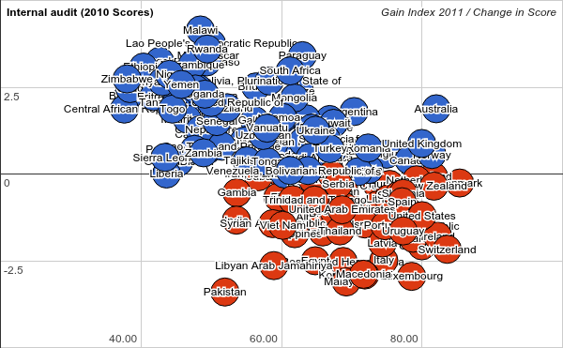

Figure 6. Shows differences in score between “GAIN 2011” and “GAIN 2012” without the additional measures for better comparison. Horizontal axis is the “Gain 2011 Legacy” Score. Vertical Axis is the percentage change in Scores compared to “Gain 2012 Update”. Negative numbers (and red color) indicate a lower score in the updated version.

The median change in scores is 0.48 percent (min -3.4 percent, max 4.15 percent). Several sources of these differences have been identified:

* Agricultural capacity composite measure.
* Re-sourcing of some of the measures includes updated or revised numbers and sometimes more data points, which means less interpolation for existing countries. Having more countries influences the ranks, but not the scores.
* Fixing bugs such as an error that allocated zero vulnerability in water capacity to some countries.
* A slightly different, more consistent approach dealing with missing numbers.

There seems to be an overall distribution of the differences correlated proportional to the score. We are still tracing the sources of the biggest differences to make sure the origin of these changes is known referenced, and understood.

### GAIN 2012 additional measures

Following the Feedback received throughout the year, we are adding two additional measures for the vulnerability axis (ecosystems and urban). Please see the Technical Description of the new measures for ecosystem services and Human Habitat.

|  |  |  |  |
| --- | --- | --- | --- |
| **Sector** | **Exposure** | **Sensitivity** | **Capacity** |
| **Water** | 🞆 🞊 | 🞆 🞊 | 🞆 🞊 |
| **Food** | 🞆 🞊 | 🞆 🞊 | 🞆 🞊 |
| **Health** | 🞆 🞊 | 🞆 🞊 | 🞆 🞊 |
| **New: Ecosystem Services** | 🞆 🞊 | 🞆 🞊 | 🞆 🞊 |
| **New: Human Habitat** | 🞆 🞊 | 🞆 🞊 | 🞆 🞊 |
| **Infrastructure** |  | | |
| Coastal | 🞆 | 🞆 |  |
| Energy | 🞆 | 🞆 |
| Transport | 🞆 | 🞆 |

## Specific Open Issues

### Website update-upgrade

There are significant improvements suggested by the users for the website. Some are feasible as additions to the current website framework, some are more suitable as an Excel file.

Some proposed website changes:

* Consistent use of matrix quadrant colors in maps.
* Improve the selection of similar countries for that tab by considering not only the overall score, but also neighboring countries, income group, etc.
* Add an ability to compare countries/sectors.
* Disaggregate dots in the Matrix according to sectors. This means the ability to place in the matrix not only the overall score for e.g. vulnerability, but also the partial scores for its components (exposure, sensitivity, capacity, food, … )
* Filter countries by range of scores in selected sectors.
* Present histogram of values for measures, to have an idea of the global spread of values.
* Resolve rank ties within the chosen uncertainty in scores. In the current ranking we only count one decimal point. New Zealand (5th) and Finland (6th) both have score 81.7. Finland would then be tied in 5th position and Norway will keep its Rank (7th).

*Excel version*: We are considering preparing a version of the Index in Excel format with more comparators and tools for advanced users.

### Readiness axis

We also recognize the importance of revisiting the readiness axis. Feedback received in this regard suggests several directions to investigate. For example, a readiness structure separating *Policies* and *Outcomes*. In combination with the three current sectors (economic, government and social) this would create a conceptual matrix similar to the vulnerability axis. There is also an issue on how to treat and distinguish adaptation Capacity (currently part of the vulnerability score) and some components of readiness.

We need to explore all these possibilities, but we have decided to focus on the priorities listed in this document for the GAIN Index 2012.

## Complementary activities of GAIN

### GAIN Index related projects

***Determining local metrics that matter to small- and medium-sized entrepreneurs***

GAIN, in partnership with the Tecnológico de Monterrey, is embarking on a year-long project to determine how small- and medium-sized enterprises (SMEs) build resilience for their operations and their communities. Focusing on sectors crucial to human well-being, agriculture, water and energy. The two institutions will engage with businesses across Mexico. The project will also advance the GAIN Index by informing efforts to scale down the Index at the national level in Mexico.

This project is made possible through the support of a grant from the John Templeton Foundation.

***North American Index***

GAIN is partnering with academic and nonprofit institutions and public and private foundations to develop a more granular, local version of the GAIN Index – beginning in North America (Mexico/United States/Canada).

Modeled after the GAIN Index, the localized index will regularly evaluate and compare climate resilience and attractiveness for private investment within each province/state and the urban areas with a population of 250,000 or more. Each locale will be evaluated based on two criteria: ‘vulnerability’ to climate impacts and ‘readiness’ to address those risks.

Every two years resiliency building efforts in each area will be reassessed and the Index will be updated to indicate improvements, declines or no change. Best practices used by the highest rated areas will be identified and highlighted. This will allow other regions to *GAIN Insight* into how they can increase their score. We believe that an Index that allows provincial/state and local governments, nonprofits and the private sector to see how they compare to other regions of their country will create a ‘race to the top’ to build resilience nationwide.

***Adaptation Knowledge Portal***

Similarly, GAIN will collaborate with academic and nonprofit institutions and public and private foundations to establish and maintain a climate resilience knowledge portal to support regional, municipal, and community climate resilience. Through this project, we will gather, distill, integrate, organize, present and market best practice, including case studies in the development of regional and local climate readiness. The knowledge portal will also host an urban resilience blog, which will focus on the latest in local climate and resilience best practice and policy.

### GAIN Prize ([GAIN.org/Prize](http://GAIN.org/Prize))

The GAIN Prizes are the first awards that recognize those organizations and entrepreneurs that are working on innovative projects and successfully tested technologies that will help the most vulnerable adapt to the changing global climate, urbanization, population growth and other global forces. These Prizes honor what has taken place on the ground working shoulder-to-shoulder with vulnerable communities on innovative adaptation solutions.  
  
Winners are judged on criteria including effectiveness, scalability, impact, marketability and relevance to the GAIN Index. Given that most resources to help countries and communities adapt will come from investments from the private sector, a particular emphasis was put on projects that have engaged the private sector as a partner in their work.

The winners of the 2012 GAIN Prizes are:

***Engineers Without Borders* — Austin Chapter** is helping to increase the resiliency of communities in Peru through their Climate Adaptation in Mountain Basins in the Andean Region (CAMBIAR) project.

***Ushahidi***is a nonprofit tech company that specializes in developing free and open source software for information collection, visualization and interactive mapping. Their technology has been used to help communities communicate during times of crisis, such as during floods and earthquakes as well as convey food and energy shortages.

***MEDA*** has created an innovative program, Technology Links for Improved Access and Incomes (Techno-Links), which provides rural farming families with access to technology, such as drip irrigation and tilling equipment, for agricultural products.

***Positive Innovation for the Next Generation (PING)*** has created the Disease Surveillance & Mapping Project in Botswana to increase the efficiency and productivity of each healthcare worker in the country.

### GAIN Knowledge ([GAIN.org/knowledge](http://GAIN.org/knowledge))

GAIN is sharing ideas and efforts with governments, NGOs, and the business community to increase awareness of the urgent need to adapt. GAIN's Annual Meetings & Scientific Convenings gather an unparalleled field of private sector, academic and government leaders to develop pragmatic adaptation solutions. Adaptation thought leaders are encouraged to contribute news, next practices and opinions at GAIN.org.

1. The Google Analytics software does not detect access to a website by some computers; for example, about 3 percent of users in the U.S. would not be tracked. More information at: en.wikipedia.org/wiki/Google\_Analytics [↑](#footnote-ref-1)
2. See Figure 4 on Technical Document on Vulnerability Variables from last year. [↑](#footnote-ref-2)
3. Note, the “GAIN 2012 Update” does not include new Ecosystem Services and Urban indicators. We were able to include more countries in the “GAIN Index 2012”. [↑](#footnote-ref-3)